Department of Computer Science

University of Bradford

**Requirements Specification Document**

Impact Project Records Dashboard Website

Team 1

Samuel Coyle 21011003 s.d.coyle@bradford.ac.uk

Ceridwen Grey 21005946 cegrey@bradford.ac.uk

Joanna Oruba 21025084 j.oruba@bradford.ac.uk

Joshua Mackey 21030482 j.f.mackay@bradford.ac.uk

Shamim Akbari Bavani 21018873 s.a.bavani@bradford.ac.uk

Table of Contents

**No table of contents entries found.**

1. Introduction:

The client (The University of Bradford’s Research Development and Impact Team) needs a central location to store and update information on research outputs and impact activities. Project Collaborators need to be able to easily access the system to upload files and data. Each impact project record consists of impact activities and evidence as well as multiple research project records which in turn hold information on Project Investigators, grants, and research outputs. Reviewers need to be able to view projects that are assigned to them, and administrators need to be able to edit all projects.

1.1 Team Member Skillsets:

**Joanna Oruba**

Competent and tireless student with experience designing and integrating advanced web applications. Proficient in architecture design, development and implementation of software applications and testing. Extensive experience working in Java-based environments. Creative person with experience coordinating with classmates to deliver project within stringent deadlines.

**Joshua Mackay**

A reliable hard worker with a proven work ethic who has achieved high marks throughout their university career. A confident programmer who has experience with Java, HTML, JavaScript, PHP, and SQL, alongside some knowledge of C# and Python. Strong teamworking skills and a proven work ethic makes them the natural choice for team leader.

**Sam Coyle**

Skilled and dedicated worker, that developed a skill set regarding databases, their function and their design. Can code competently, demonstrated through the Fundamentals of Programming module, and the Software design and development module. Will ensure hard work is given towards this project, and that it is completed to a high standard.

**Ceridwen Grey**

Focused and determined student, with extensive team working skills highly applicable to this project. A capable programmer demonstrated through various modules throughout their university course and confident in database driven languages such as SQL. Dedicated to the quality of production of their work thus ensuring this project is produced to a high standard and in a professional manner.

**Shamim Akbari Bavani**

Developed a dynamic website using JavaScript, CSS, PHP, SQL, and HTML programming languages as part of a project, and have a strong knowledge of Object-Oriented languages. Demonstrate adequate teamwork abilities, motivated, reliable, well organised, and enthusiastic about developing her skills. Dedicated and motivated to rise to any challenge.

1.2 Project Selection Reasons:

After considering the possible projects, we decided that this project provided the best match for our existing skills and a good opportunity to develop them further. We also found the chance to directly assist the university interesting, and we believed that the close proximity would make it easier to stay in contact with the client improving our chances of making an effective product.

2. Functional and Non- Functional Requirements

2.1 Actors

|  |  |
| --- | --- |
| **Actors** | **Use cases** |
| Administrator | 1. Enter Email and password to register/log in 2. Verify Email and password 3. Display log in error 4. Prompt for re-entry for X number of times 5. View all information 6. Edit all information (any impact record) 7. Access the dashboard 8. Categorise the projects 9. Rate the projects 10. Search through any impact records 11. Download any impact record 12. View and track downloaded records (by who and when) 13. View and track edited impact records (by who and when) 14. Access master spread sheet 15. Log out |
| Project Collaborator | 1. Enter Email and password to register/log in 2. Verify Email and password 3. Display log in error 4. Prompt for re-entry for X number of times 5. Upload data and files (impact records) 6. View their own project 7. Edit their own impact records 8. Download their own impact records 9. Download permitted impact records 10. Log out |
| Reviewer | 1. Enter Email and password to register/log in 2. Verify Email and password 3. Display log in error 4. Prompt for re-entry for X number of times 5. View the specific multiple permitted projects 6. Download permitted impact records (permitted by admin) 7. Not edit impact records 8. Log out |
| Database | 1. Authenticate users 2. Keep track of the identity of the collaborators and reviewers being attached to the project. 3. Update files that contains details. |

2.2 UML Use Case Diagram

(Use case diagram is done based on functional requirements but can be edited based on the interface)

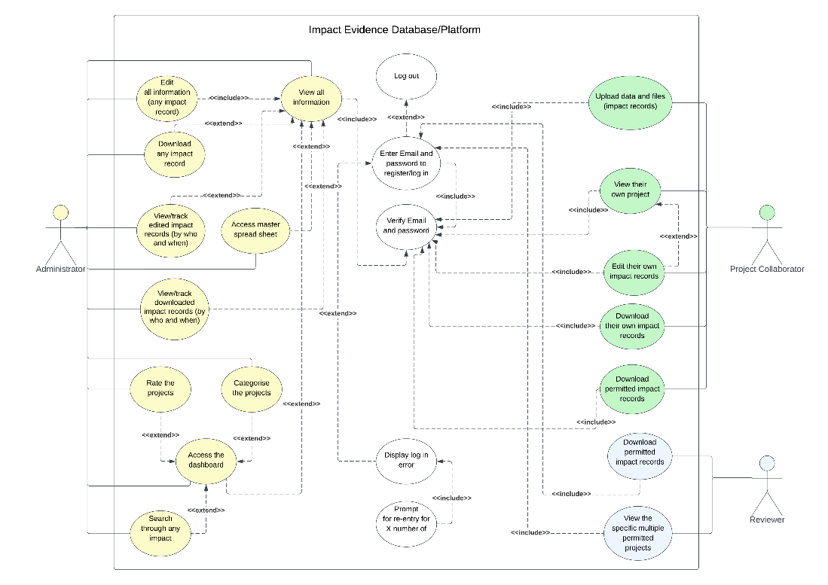

2.3 System Functions and Descriptions

**Actors:**

This system will have three user groups, referred to as actors. These would be an Administrator, Project Collaborators, and Reviewers. Administrators will have all permissions within the system and can edit/delete at will. Collaborators can only upload/edit/delete their own submissions and can only view their own material. While reviewers can be assigned material provided by Project Collaborators and view/review but not delete.

The system will provide an interface. This interface has a login page and a stop option. Once the stop option is selected the interface will close and the system will require a login on the next use. See section 4 for specifics.

**Functions:**

**System registration.** Reviewers and Project Collaborators must register to use the system. These users must create an email and password combination. The email must not already be in use and must be unique.

**System login/logout.** All users must login to the system, and logout at the end of the session. All users will login with an **email** and password combination. Once entered this combination will be validated, and allow entry if correct, and if not prompt for re-entry.All user's logout at the end of the session.

**Handling impact records.** Will be uploaded by the collaborators and reviewer's user groups. These records will be automated to link into the master spreadsheet for review by the admin. These records will be editable by the collaborator that uploaded it, and any reviewers that are assigned to these documents will be able to view them. The admin will be able to edit/delete and view these documents.

**Upload.** The Project Collaborators user group will have permissions to upload impact records. These impact records will match the formatting presented in Section 3 – Data description: Project name, Collaborators, Summary, Grants, Stakeholders, Interactions, Potential for impact, Output and Summary.

**Download.** Project Collaborators can download their own impact records, and any impact records they have been given permission to interact with. Admins can download any impact record, while Reviewers can download the impact records they have been assigned to review by the admin.Who has uploaded what and when will be tracked and be viewable by the admin.

**Editing.** Project Collaborators can edit their own impact records, Admins can edit any impact record, and reviewers cannot edit impact records. Impact records can be edited individually, row by row, and entirely. Linkage of impact records.

**Impact records will link to a master spreadsheet.** This master’s spreadsheet will only be accessible to the admin of the system and will be automated. Once data is fed into this master spreadsheet, it will be sorted by category,and be hyperlinked with the location of the file.This spreadsheet contains: Title, PI, Summary, Potential UOA, Impact progress, Notes, Meetings, Follow-Up, Research, Reach, Significance and Quality of evidence.

**Impact records will link to a dashboard.** This dashboard is only viewable by the admin of the system and will be used to rate projects. This dashboard will be automated with data coming in from uploaded impact records. These impact records will populate: Total records, Percentage of total records that are: Advanced, in delivery, REF follow on, Early stage, In development, and unknown.A search bar will be available to search through any impact records, and then display the specific information about the impact record.

2.3 Non-Functional Requirements

The system must always be easily accessible by the userbase. The system also needs to be able to handle a variety of file types including images and video.

3. Data Description

Our system tracks the following data:

**Administrator:** Has an email and password.

**Reviewer:** Has email and password and is managed by the administrator. Can also be a collaborator.

**Collaborator:** Has email and password and is managed by the administrator. Can also be a Reviewer.

**Impact Record:** Holds Research project records, Impact activities and Impact evidence.

**Research project record:** Hold information on Project Investigator, Grants, and Research outputs.

**Impact Pipeline spreadsheet:** Holds all information regarding individual impact records.

Database tables:

**users:**

UserID - Auto-incremented primary key

email - Email of the Reviewer, must have domain.

password– Encrypted password for the Reviewer, must be over 8 characters.

admin – flags if the user is an administrator

collab – flags if the user is a collaborator

reviewer – flags if the user is a reviewer

**Impact_record:**

impactID – Auto-incremented primary key

impactActivities – Activity taken to further the impact of the project.

impactEvidence – Description of evidence provided, along with a link to the location of the evidence.

researchID – Foreign key to link to relevant research project

**Research_project:**

projectID – Auto-incremented primary key

projectTitle – Title of the research project

departmetnetID – foreign key of the department that the research project is attached to

projectInvestigator – Who is the project investigator, stored as first and last name.

researchOutput – Summary of the output of the paper, along with a link to the location of the output.

grantID – foreign key

**research_grant:**

grantID – Auto-incremented primary key

amount – How much the grant was for.

dateGiven– When the grant was goven

givenBy – Who gave the grant

**departments:**

departmentID – Auto-incremented primary key

departmentName– Name of department

**project_allocations:**

userID – The id of the user assigned to the project

projectID– The id of the project the user is assigned to

role– The role of the user towards the project, 0 if they are a collaborator or 1 if they are a reviewer

**Impact Pipeline Spreadsheet:**

projectTitle – Title of project, plain text.

pI – Name of Project Investigator.

projectSummary – Summary of project.

potentialUOA – Potential of the project.

impactProgress – Progress into research.

impactNotes – Notes on research.

meetings – Any meetings that have happened.

followUp – Check in of progress.

underpinnedResearch – Any research that this current research is based upon.

reach – Who will this research reach.

significance – The significance of this research in its particular field.

qualOfEvidence – Quality of evidence provided, how circumstantial etc.

4. Class diagram:

(Class diagram is done based on the data description and needs to be updated based on the code)

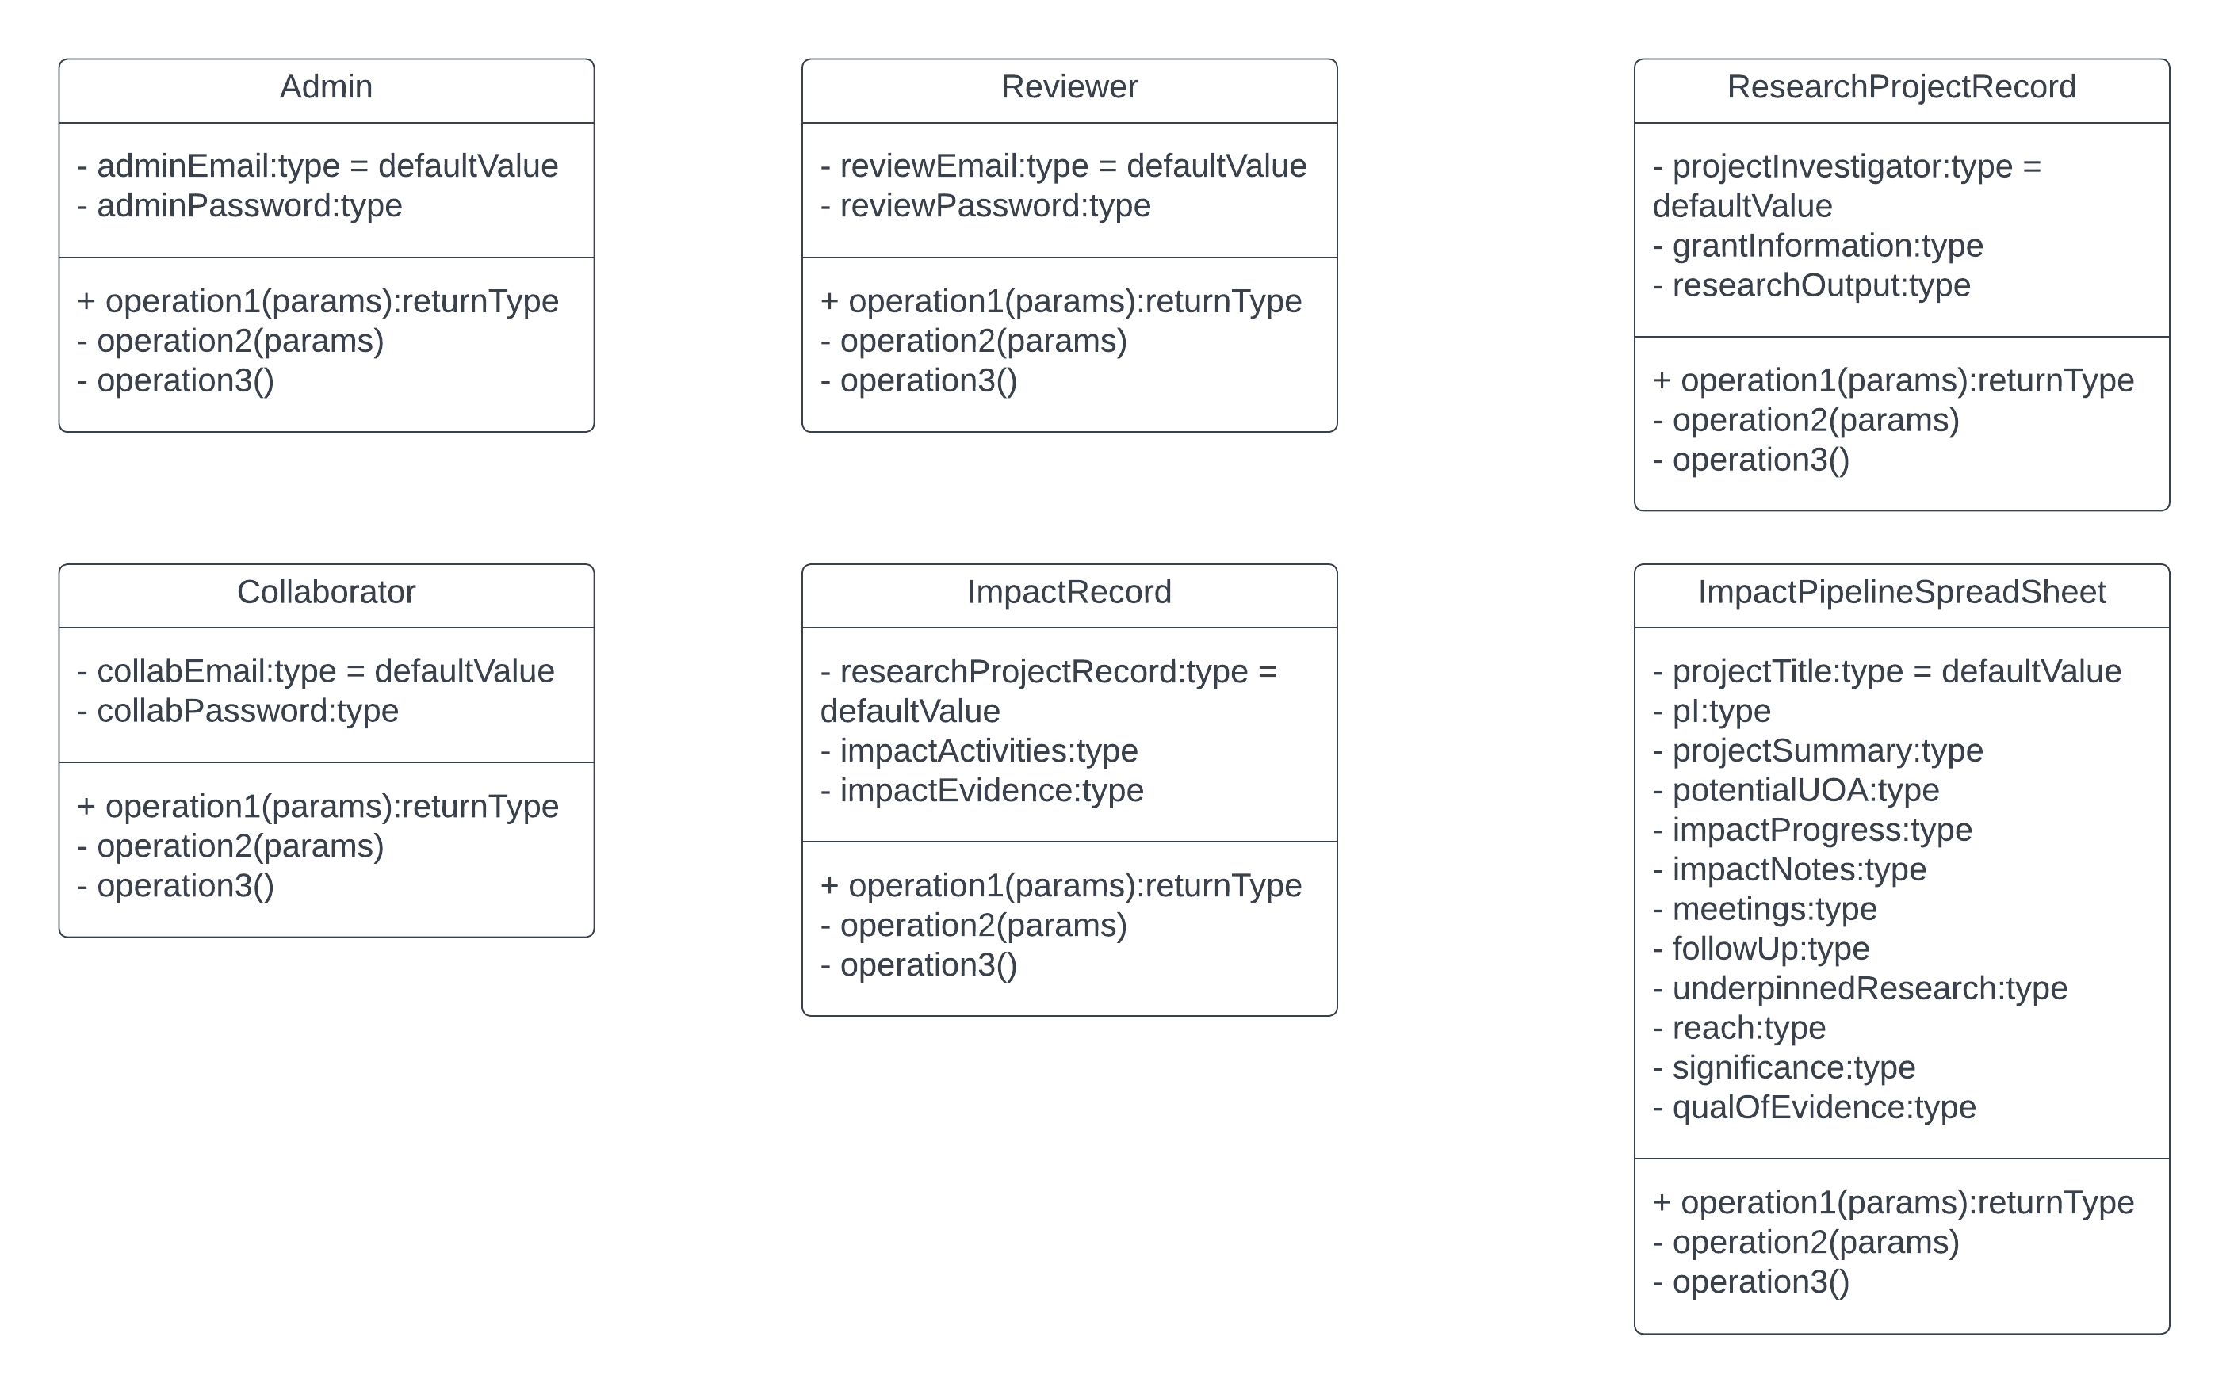

5. Interface

Log in page for admin, reviewers/collaborators – an account will already have to be set up and approved to be able to successfully log in.

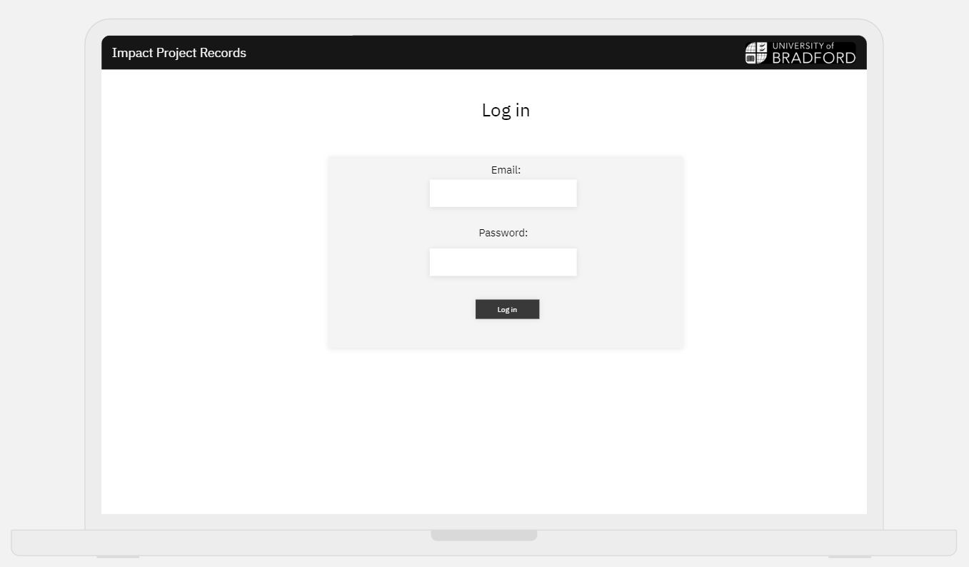

Page to register for an account – all new accounts must be authorised with the administrator, new accounts are added to the database for the admin to keep a clear record of all users and their details.

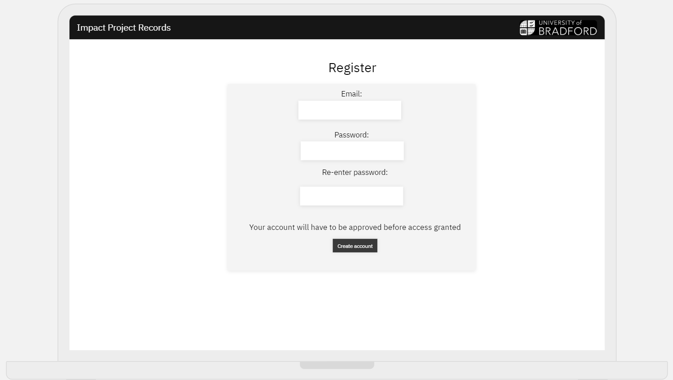

Administrator Home Page – this is the home page that the administrator will see when they log in, it has all the access points directly on the home page for easy navigation, the dashboard and master spreadsheet are unique to the admin, the admin has all access rights and can edit and view all uploaded materials.

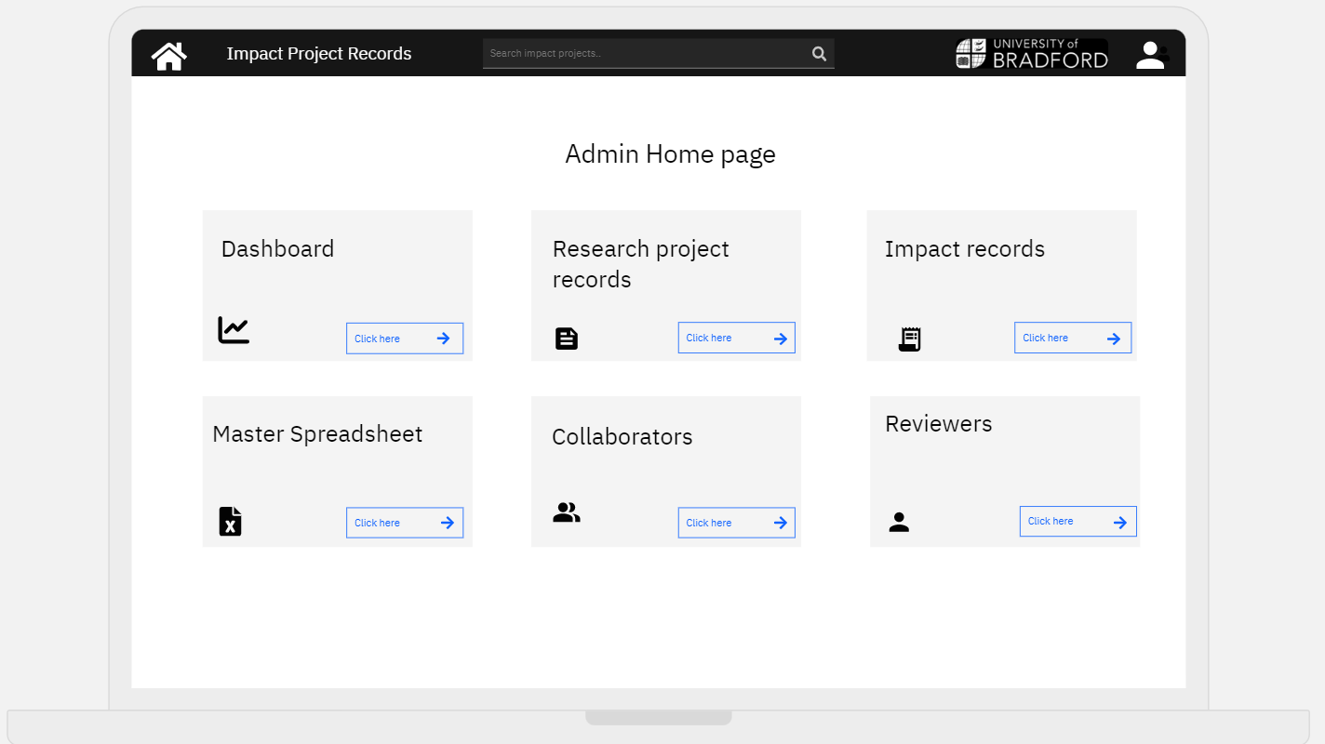

Home page for all users – it contains all access points that users have access to directly on the home page for easy navigation, access rights are to view all records as well as access a list of all collaborators and reviewers.

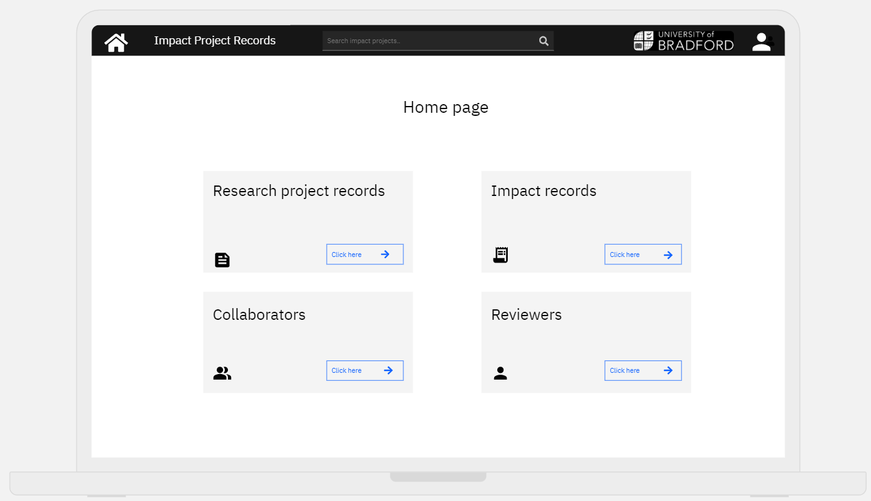

Dashboard page – This is the dashboard that the administrator has access to, it contains infographics which easily explain different categories of data relating to the files uploaded. This allows the administrator to quickly access vital information from which further actions can be taken.

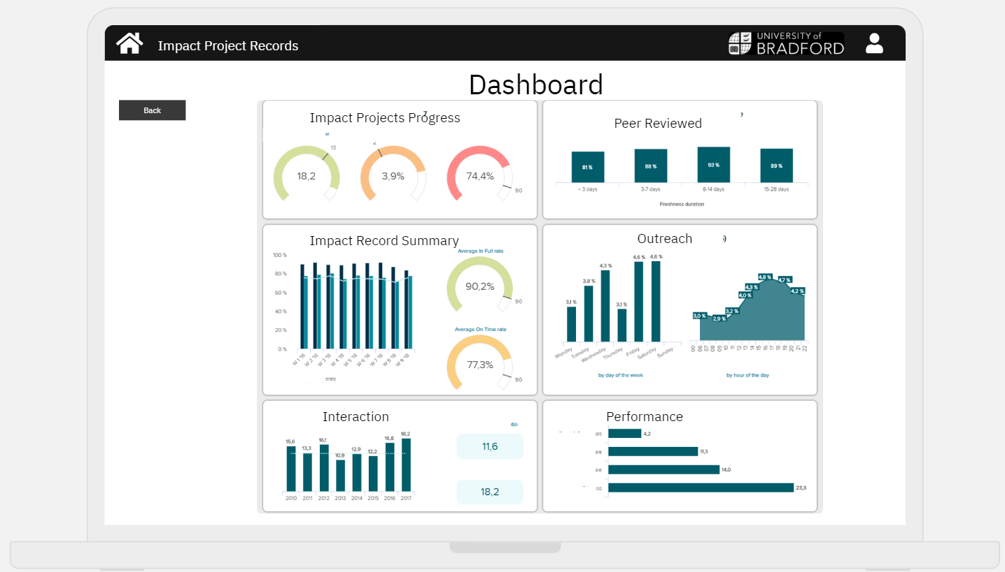 Impact/ project records screen – these screens contain all the uploaded files associated with each project, there is a drop-down list which contains the options for each faculty or display all, this allows for easier browsing of the records. There will be 3 buttons to click on which take the user to either view, upload or edit. The upload button will contain the upload template provided to us by the client, the view and edit buttons will take the user to the list of all records from there they can use which one they would like to view or edit.

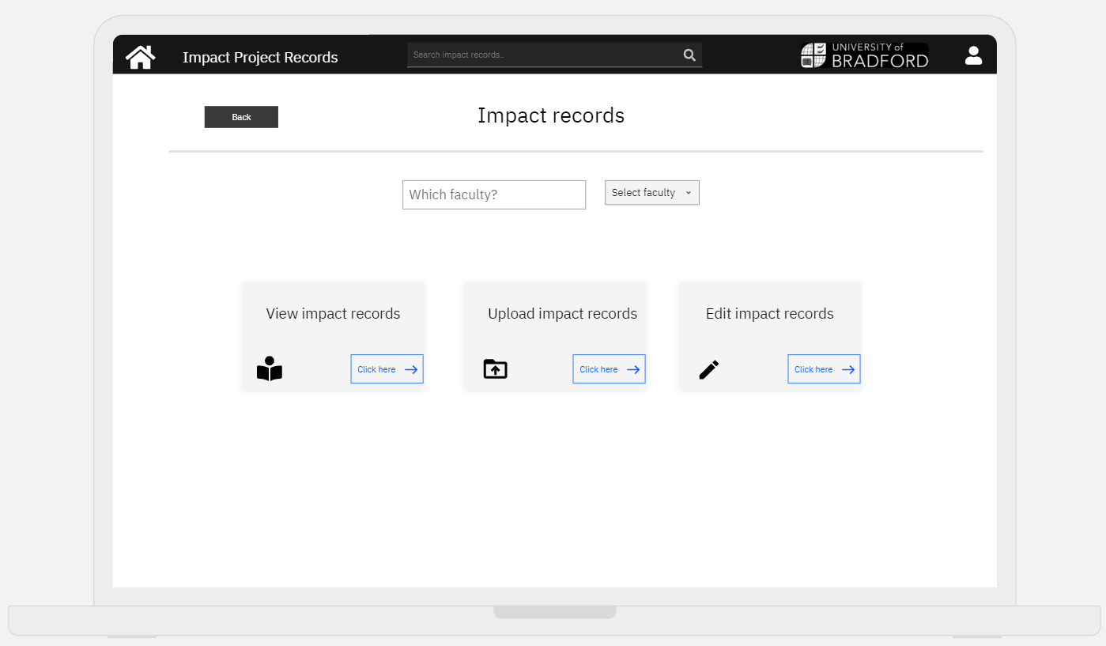 Collaborators/ Reviewers – this screen displays a list of the collaborators/ reviewers, where results can be filters based on categories such as alphabetical or department. This page is the same for reviewers.

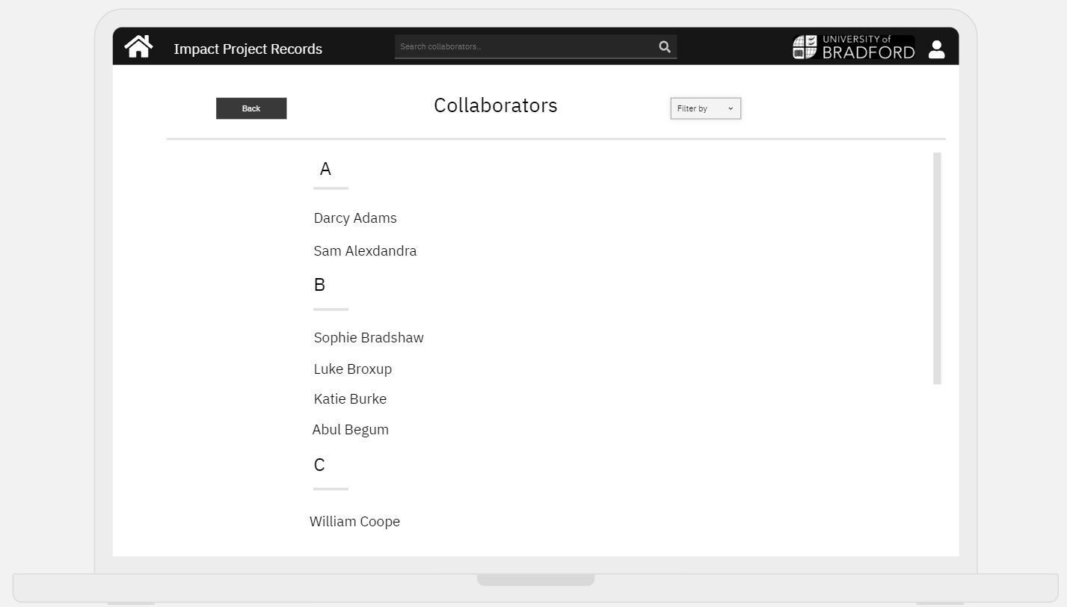

Reviewers/Collaborators records page – this screen will be accessible by selecting the specific reviewer or collaborator that is required, then the page will display all records related to this reviewer/collaborator, if the selected reviewer/collaborator is the user logged in or the administrator then they will have the displayed options to the right meaning they can upload or edit, whereas other users will only be able to view. This ensures access rights are kept to those whose records belong to them whilst including the administrator. This page is the same for the collaborators and reviewers.

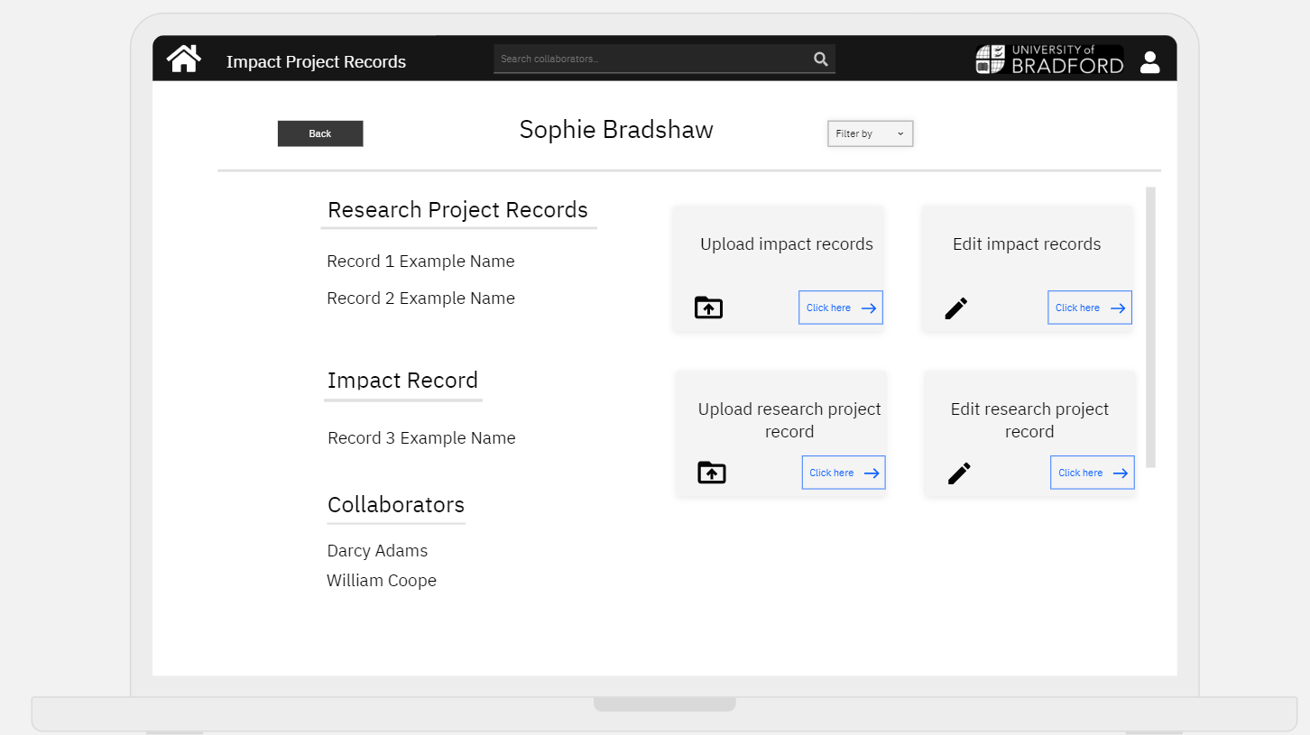

Upload Impact/Research record file - this screen will be accessible by a button from the previous screen, the file will then be able to be uploaded by clicking the box displayed below and the user will be prompted to browse their device to choose a file to upload. 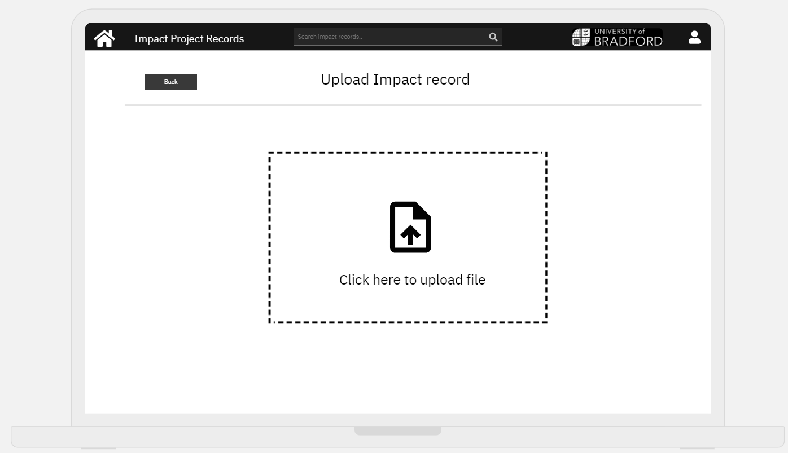

6. Others

6.1 LSEPI:

Legal:

Legal issues in Software Development are the laws associated which must not be broken in order to complete the project with no issues. In this project, our Team and the Client we are working with must adhere to these laws:

* Any signed non-disclosure agreements (NDAs) – this is a legally enforceable contract which creates a confidential relationship between a person who has sensitive information and another person who will gain access to that information. In our project this relates to the details of each reviewer and collaborator, as well as the data that the client currently holds (figures for each data impact project)
* GDPR 2016 – this is the General Data Protection Regulation which provides a legal framework for allowing everyone’s data to be kept safe as companies are legally required to have secure processes in place to handle and store sensitive information.
* Computer misuse act 1990.
* Software licenses

Ethical:

Ethics define socially acceptable behaviours, which are based on the cultural mores.

While developing the system it matters to ensure, that the information or systems are not misused. Selecting accurate testing and system validation are the most efficient for predicting errors and any issues with software. Businesses must ensure that all data is protected and secured.

Social:

Building effectively working team is a great way to achieve the best results in a project. However, the respect and inclusion within the team members can benefit in achieving the goal. Following this, the purpose of the project must be of benefit for the client, as well as users. Anyone can use our system, regardless of ethnicity or belief.

Professional:

The software must meet client expectations. We need to deliver the project on time, we cannot have any delays.

6.2 Risk assessment:

The following risks have been identified to reduce the chance of failure of this project:

1. **Communication risk** - Poorly established communication with client or between team members can lead to delays or confusion for the project, this results in clients who are unhappy with the standard/progress of the work or project direction being taken away from what client wanted. Client not responding to the correspondence can lead to project delays or halt the team as they are unable to ask further questions or show progress to client to confirm that project direction is correct.

|  |  |  |  |
| --- | --- | --- | --- |
| Affects | How | Immediate control measures | How this relates our project |
| Client, Team Members, Stakeholders | Affects client as their project will not be completed, affects team members as project deadline may not be met and this reflects badly on them and their reputation to be capable of completing projects, affects stakeholders as deadlines will not be met therefore negatively impacting their business. | Clear lines of communication set up between client and team to ensure each party know where to contact the other, first interview in person check the communication line is correct and working properly to prevent confusion, another contact should be provided from the client's teams allowing them to be contacted for support to allow for a different communication line if client unresponsive. | Clear line of communication established in first meeting with client, project is for University of Bradford therefore in person contact is available if necessary and can be arranged during office hours. |

1. **Schedule risk** – A delay in the work plan due to the team being unorganised for reasons such as prioritising the tasks in wrong order, or miscommunication in the team can result in exceeding the deadline.

|  |  |  |  |
| --- | --- | --- | --- |
| Affects | How | Immediate control measures | How this relates to our project |
| Client, Stakeholders | Clients are unhappy with the rate of work, client cannot proceed with the original work procedure time as an unexpected delay has occurred, changes cannot be made if clients are unsatisfied as no extra time has been given to amend them, stakeholders' business can be negatively impacted if project was planned to elevate their business. | A Gantt Chart can be made to visually see all tasks and their dependencies can help determine with tasks should be prioritised and those tasks cannot be completed without the previous ones, this helps team members understand their priorities and to ensure they are completed to proceed with the project. Clear minutes meetings detailing which tasks are to be allocated to who and when they should be completed by. | 1-2 weekly team meetings are scheduled, with minutes being taken and written done with takes clearly allocated to team members with the date needed, when it reaches this date, the tasks are reviewed, and progress needs to be shown. |

1. **Efficiency risk** – Team members work ethic not being what is needed or expected from them, and work produced being of poor quality can lead to the development of the project being slow and not on schedule. Ultimately this means that the project is not up to the standard that is expected by the client, or the deadline not being met.

|  |  |  |  |
| --- | --- | --- | --- |
| Affects | How | Immediate control measures | How this relates to our project |
| Team members, Client, Stakeholder | Pressure is put on all members of the team if certain members performing well as the team will inevitably need to meet the deadlines so will stretch their own time to complete the work of others. Clients do not want to have invested their time, money and resources to a team who is inefficient and unprofessional in their work ethic, this reflects badly on the client as their choice for who should complete their project was poor and will not be taken well by stakeholders whose business is affected by poor standards of work or unmet deadlines. | A Gantt Chart being made to display how long each task should take helps to clearly understand the schedules which need to be stuck to in order to produce the project on time, tasks should be reviewed by more than one person to receive varying opinions and ensure that everyone is happy with the standard and rate of work. | Weekly team meetings where the tasks from the previous are reviewed and discussed by all team meetings and all feedback given is taken into consideration, a time frame is allocated to reassess the task to ensure that all tasks are completed on schedule and progression of the project can continue. |

1. **Professional risk** – the quality of the code being weak/faulty as well as unreliable testing issues causing bugs and rendering it unusable by the user or by the client.

|  |  |  |  |
| --- | --- | --- | --- |
| Affects | How | Immediate control measures | How this relates to our project |
| User, Client, Stakeholder | If the projects code does not work then the brief simply has not been met, this means the team has not completed the project and affects the client as they do not have a project that can carry out their wishes. Faulty code or code with bugs affects the user as it may crash on them or simply not work, this leads the user to not feel as though the company they are using the code through is reliable and thus reflects badly on the client who the project was for. A bad reputation for faulty or bad code then affects stakeholders as it could negatively affect their business. | Code which is written needs to be clear and concise and not contain any faults or bugs that could lead to more complications. Any faults need to be rewritten and accessed by the team if any problems occur. Code needs to be tested to ensure that no future faults could occur. | Weekly team meetings where any issues faced during that week can be addressed, if any team members are struggling to rectify their code, then an issue should be raised at the team meeting where further action can be carried out to fix the code. Testing is carried out throughout the projects development to ensure that no part of the code is faulty and does not go undected. |

**Attached below are the GitHub Links to relevant files required from Team 1**

Work plan

Peer review

Team Minutes and Work Assignment

Risk Assessment

Review and planning (Gantt Chart)

NDAs

GitHub link